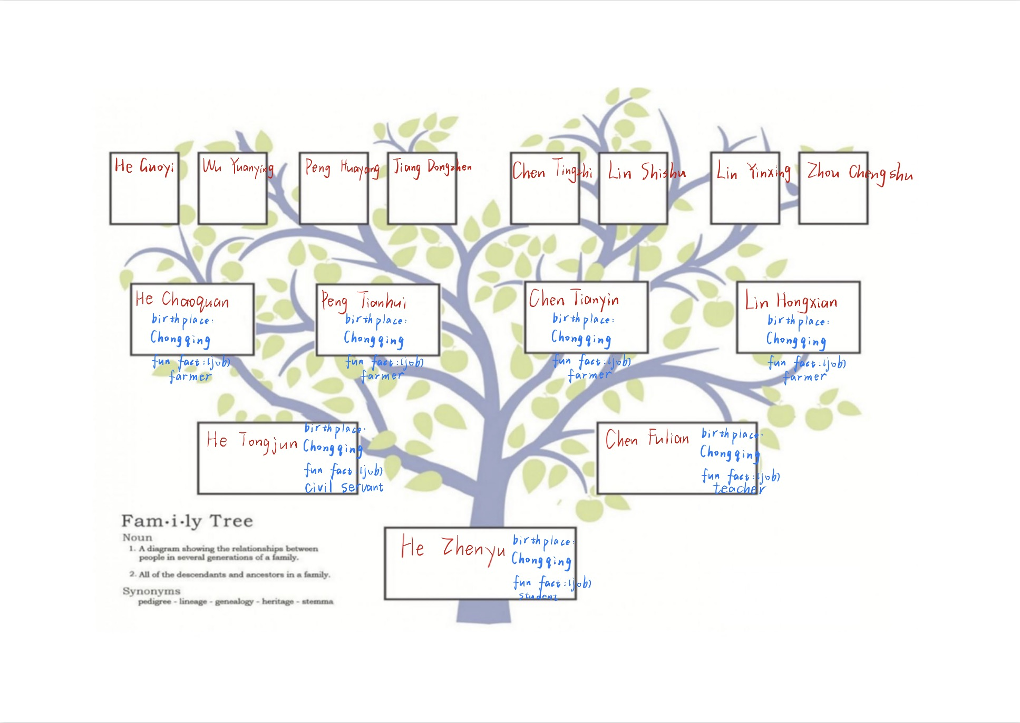
Questions:
- What was your childhood like?
- *Why was your childhood happy?
- What were your parents like?
- What were important values or traditions in your family?
- How did you meet your spouse?
- *What do you think of your spouse?
- What was your favorite and least favorite subject in primary school?
- *Why do you like it?
- Is there a story behind your name?
- Describe your home or neighborhood where you grew up?

My Reflection on Mom’s Interview: Learn More About Her and Me
Last weekend, we had this interview through WeChat video call, and we talked very happily. Through this interview, I learn a lot about Mom’s family story, values, and how they make her be who she is, and how that influences me. What surprise and impress me is that every little thing, like tradition, story, and value, are all connected, like a big picture of our family.
What Surprised Me
Two things make me feel wow. First, Mom’s love story with Dad is very interesting. They met because Mom’s colleague and Dad’s colleague were a couple, so they introduced Mom and Dad. It’s like a small world, and I feel surprised about this.
Second, the meaning of Mom’s name is to be like a lotus, clean and noble even in mud. Mom never think too much about it before, but now we know her family hoped she could be a good person with integrity. This makes me feel impressed.
Family Values and Traditions in Mom’s Family
In Mom’s family, they value respecting elders and caring for young ones very much. They call this “xiao” , it’s a very important tradition. Every important festival, like Spring Festival, they all get together. They eat dinner, talk, and have fun. It’s a big family party, and they all love it.
Also, birthday is a big thing. They have cake, gifts, and eat together. It’s a way to show that every family member is loved and important.
How Mom’s Family History Influenced Her (and Then Me)
Mom’s parents (my grandparents) are hardworking and kind. They never hit or scold Mom, so Mom’s childhood was very happy. She played a lot with her brothers and sisters, and they got along very well. This makes Mom a person who is friendly and likes to help others, and that’s why I grow up in a warm family too.
In primary school, Mom’s favorite subjects were math, physics, and chemistry. Because when she solved a problem, she felt very proud. Her parents always encouraged her to study, so she loves learning these subjects, and she also encouraged me to love studying.
Connecting to Family Types We Studied
Mom’s family is a nuclear family (with her parents and siblings), but they also have extended family connections. Because they value traditions and “xiao”, so it’s like a mix of modern and traditional family type.
All in all, this interview let me know more about Mom’s family and how it shapes me. Every story, value, and tradition are part of Mom, and also part of me. I think Mom’s family history is not just past, it’s still making her and me grow and be better people. After this interview, I really want to chat with Mom more about our family’s old tales. I’m so thankful for her sharing and our family’s warm values. These stories make me feel rooted, and I will keep these traditions and pass them on. Family is truly the best treasure, and I hope to have more such sweet talks with Mom in the future.

